 

CSE 5009 – Web Application Development

INDIVIDUAL ASSIGNMENT

|  |  |  |
| --- | --- | --- |
| **Qualification** | | **Module Number and Title** |
| Higher Diploma in Computing and Software  Engineering | | Web Application Development - Website for  **“Signature cuisine”** restaurant |
| **Student Name & No.** | | **Assessor** |
| Name: Dissanayake don Didula madushan nirasha Dissanayake  ICBT ID: GM/HDCSE/CMU/04/26 | | Mrs. Kavindda |
| **Hand out date** | | **Submission Date** |
| 00/00/00 | | 00/00/00 |
| **Assessment type**  WRIT1 -  Coursework | **Duration/Length of Assessment Type** 3000 words equivalent | **Weighting of Assessment**  100% |

I certify that the work submitted for this assignment is my own and research sources are fully acknowledged.

**Learner declaration**

|  |  |  |  |
| --- | --- | --- | --- |
| **Marks Awarded** | | | |
| First assessor | |  | |
| IV marks | |  | |
| Agreed grade | |  | |
| Signature of the assessor |  | Date |  |

**FEEDBACK FORM**

**INTERNATIONAL COLLEGE OF BUSINESS & TECHNOLOGY**

**Module:** Web Application Development - Website for **“Signature cuisine”** restaurant

**Student:** Dissanayake don Didula madushan nirasha Dissanayake

ICBT ID: GM/HDCSE/CMU/04/26

**Assessor:**

**Assignment: CSE 5009 – Web Application Development**

**Strong features of your work:**

**Areas for improvement:**

**Marks Awarded:**

**Acknowledgement**

I would like to thank my professor for guiding me throughout the course of

this assignment. he was there to help me every step of the way, and his motivation is what helped me complete this assignment successfully. I thank all the teachers who helped me by providing the equipment when necessary. I would also like to express my sincere gratitude to my friends and parents, who

stood

Task 1

A

*The Cheesecake Factory*

" The Cheesecake Factory," a culinary treasure among confection shops, stands as a testament to the world of sweet indulgence. As its name implies, this distinguished establishment is each about after

and galettes, and it does so with an unexampled excellence that has earned it transnational recognition. Its heritage as a famed confection shop has placed it among the culinary nobility, where it has pleased patrons with its exceptional confectionary creations. What sets" The Cheesecake Factory” piecemeal is its unvarying commitment to delivering the ideal cate

experience. From the moment you step through its doors, you are transported into a world of sweet delights. The air is designed to produce a warm and inviting atmosphere, evocative of a traditional confection shop, complete with the infectious aroma of lately ignited after. Located in a high spot in the heart of the megacity, it offers the perfect background for your culinary trip. The mix of heritage and agreeableness creates an terrain that's both comforting and culturally rich. One of the emblems of" The Cheesecake Factory" is its quick service. The devoted staff ensures that your cate

experience isn't only exquisite but also effective. Whether you are a original patron looking for a quick and satisfying confection or a caller exploring the megacity’s culinary scene, the confection shop's prompt service ensures that you can savor the agreeableness without detention. Now, let's talk about the star of the show — the after and galettes. At" The Cheesecake Factory," the menu is a treasure trove for cate suckers. The confection shop's commitment to delivering the freshest and most tasteful after and galettes is apparent in every creation. While there is an array of choices, there are a many name particulars that you simply must try. First and foremost, the Cheesecake takes center stage. This hand cate is a symphony of flavors, where the delicate uproariousness of cheesecake meets a tasteful crust, creating a pleasurable discrepancy that will tantalize your taste kids. The result is a cate masterpiece that defines the substance of" The Cheesecake Factory." The Chocolate Fudge cutlet is another delight not to be missed. wettish layers of chocolate cutlet are freehandedly frosted with satiny chocolate fudge, creating a medley of flavors and textures that's nothing short of extraordinary. It's a testament to the confection shop's commitment to using the finest constituents and showcasing them in a way that elevates your experience. For those seeking an volition to galettes, the Fruit cocottes are a must- pass. These cocottes combine short, caloric confection shells with a luscious fruit stuffing, delivering a burst of flavors that offer a pleasurable departure from the cutlet- centric menu. As for the confection shop's functional hours, it caters to your cate needs all through the day. The doors are open from 8 AM to 8 PM, icing that you can satisfy your sweet jones at your convenience. In conclusion," The Cheesecake Factory" isn't just a confection shop; it's an institution that encapsulates the substance of the world. With its traditional air, nippy service, and an extraordinary menu, it offers a cate

experience that's both memorable and exceptional. Whether you are a original occupant or a caller to the megacity, a visit to" The Cheesecake Factory" is a sweet trip that shouldn't be missed. It's a festivity of afters, galettes, and culinary excellence all rolled into one, making it a truly iconic destination in the heart of the megacity for those with a sweet tooth. Their home runner Their menu The website for" The Cheesecake Factory" is a witching

digital platform that provides a wealth of information about this confection shop, offering an enticing and instructional stoner experience. The website engages callers with appealing prints, a harmonious color palette, and courteously designed rudiments. " The Cheesecake Factory" website showcases the wide variety of taste and galettes they offer, accompanied by detailed information about their prices. This transparent approach to pricing is a precious resource for implicit guests, allowing them to plan their sweet indulgence while considering their budget. The website also highlights that confection prices can vary depending on the size and type of confection, furnishing clear perceptivity into the cost structure. An exceptional point of the website is the option to download the complete confection menu in PDF format. This position of availability and convenience is largely appreciated by druggies who prefer to read the menu at their rest or partake it with musketeers and family. It's a testament to the confection shop's commitment to furnishing information in a stoner-friendly manner. also, the website excels in conveying information about the confection shop's operating hours throughout the time. This is essential for guests, both regular and new, as it enables them to plan their visits and ensures they will not miss the occasion to savor the pleasurable after

It reflects the website's fidelity to enhancing the stoner experience. In conclusion," The Cheesecake Factory" website is an exemplary digital platform, seamlessly combining visual appeal with precious information, creating a compelling online presence for the confection shop. It serves as a model for other businesses in the confectionary assiduity seeking to engage and inform their followership effectively. Chang's China Bistro

* **Their home page**

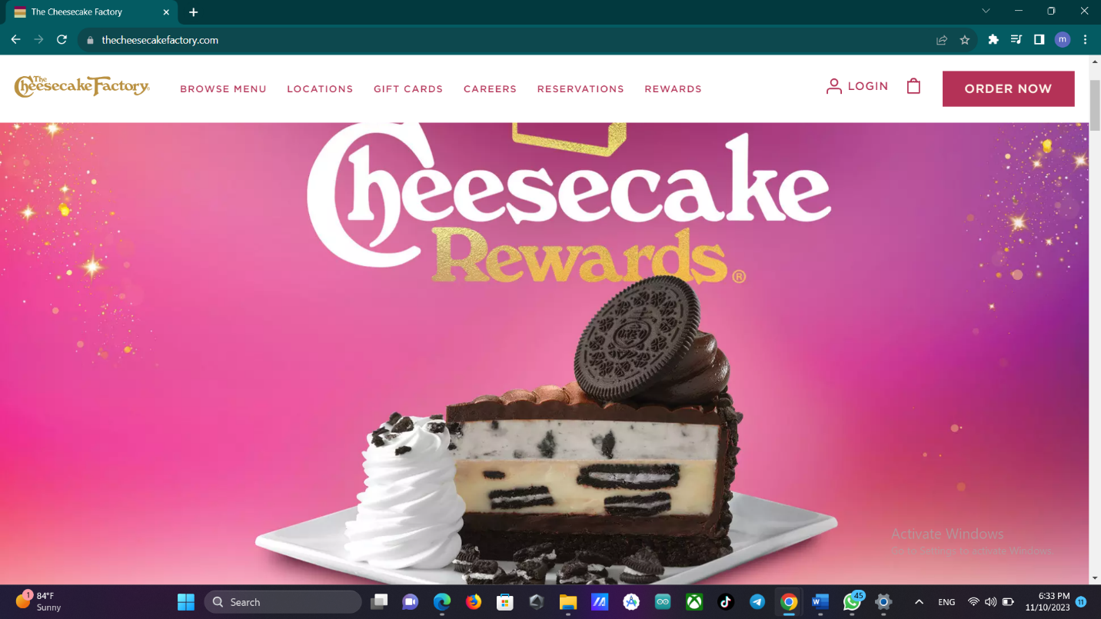

* **Their menu**

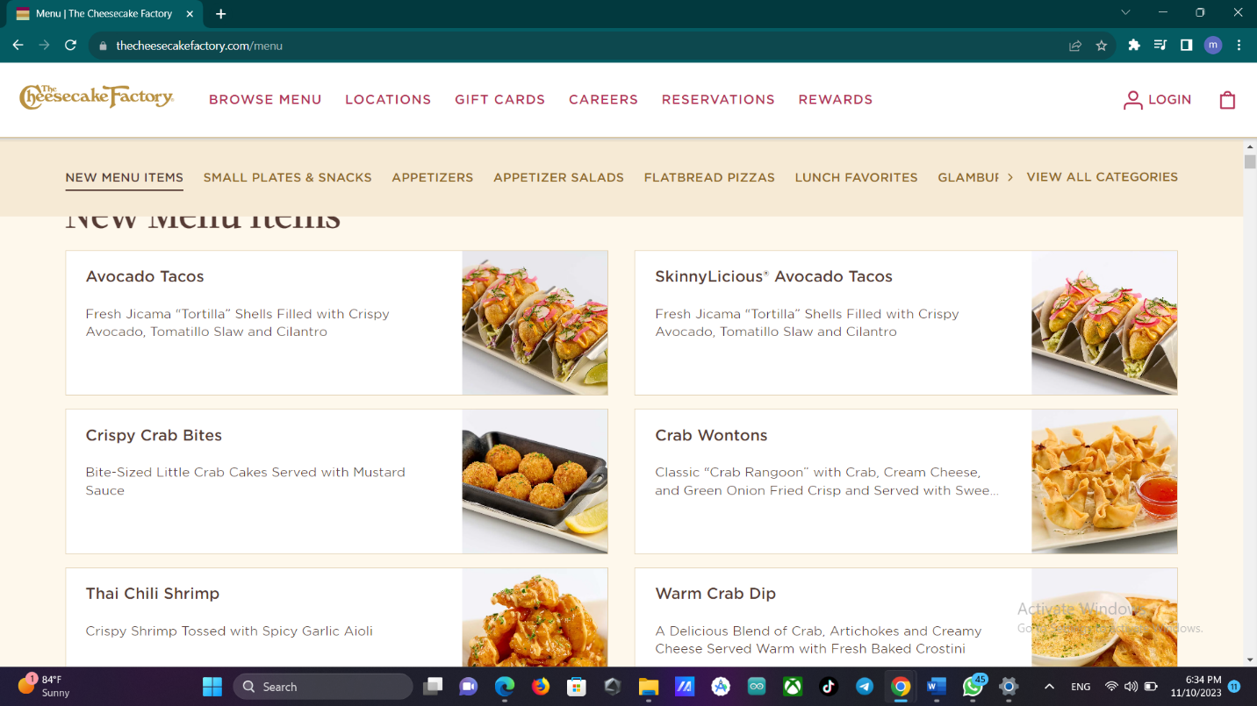

The website for "The Cheesecake Factory" is a captivating digital platform that provides a wealth of information about this pastry shop, offering an enticing and informative user experience. The website engages visitors with appealing photos, a harmonious color palette, and thoughtfully designed elements.

"The Cheesecake Factory" website showcases the wide variety of delectable pastries and cakes they offer, accompanied by detailed information about their prices. This transparent approach to pricing is a valuable resource for potential customers, allowing them to plan their sweet indulgence while considering their budget. The website also highlights that pastry prices can vary depending on the size and type of pastry, providing clear insights into the cost structure.

An exceptional feature of the website is the option to download the complete pastry menu in PDF format. This level of accessibility and convenience is highly appreciated by users who prefer to peruse the menu at their leisure or share it with friends and family. It's a testament to the pastry shop's commitment to providing information in a user-friendly manner.

Moreover, the website excels in conveying information about the pastry shop's operating hours throughout the year. This is essential for customers, both regular and new, as it enables them to plan their visits and ensures they won't miss the opportunity to savor the delightful pastries. It reflects the website's dedication to enhancing the user experience.

In conclusion, "The Cheesecake Factory" website is an exemplary digital platform, seamlessly combining visual appeal with valuable information, creating a compelling online presence for the pastry shop. It serves as a model for other businesses in the confectionery industry seeking to engage and inform their audience effectively.

*P.F. Chang's China Bistro*

P.F. Chang's China Bistro, a famed Chinese and Asian food eatery, boasts a website that isn't only dependable but also rich in content. It's a digital gateway to a world of tasteful culinary gests , and it leaves no gravestone unturned when it comes to furnishing precious information to its callers. The eatery's menu is a show of different food selections, reflecting the wide range of Chinese and Asian dishes it offers. From savory dim sum to racy Sichuan specialties, the menu is designed to feed to a variety of tastes and preferences. This diversity is a hallmark off. Chang's commitment to offering an authentic and satisfying dining experience. One of the most prominent features of the website is its capability to display the colorful locales off. Chang's China Bistro. Whether you are looking for the nearest eatery in your megacity or planning to dine at a specific position while traveling, the website provides the essential information you need. This convenience is greatly appreciated by patrons who value availability and ease of navigation. The visual appeal of the website is another name aspect. witching photos of the dishes and the eatery's air engage callers, allowing them to nearly savor the experience before indeed setting bottom in the eatery. The artful donation of dishes, the inviting innards, and the vibrant atmosphere are all effectively conveyed through these images, creating a strong desire to dine atP.F. Chang's. Communication is crucial, and the website ensures that callers can fluently get in touch with the eatery. Whether it's making reservations, seeking answers to inquiries, or furnishing feedback, the website facilitates these relations seamlessly. This position of responsiveness and availability enhances the overall client experience, making it a stoner-friendly platform. Beyond these features. Chang's website is a treasure trove of information about the eatery. It goes beyond simply showcasing the menu and locales, furnishing perceptivity into the eatery's gospel, its commitment to quality, and indeed participating stories about the origins of certain dishes. This depth of content adds a subcaste of authenticity and translucency, giving guests a deeper understanding of the dining experience they can anticipate. In conclusion. Chang's China Bistro's website is a dependable and comprehensive digital platform that goes the redundant afar in offering a rich and instructional experience. It isn't only a practical tool for finding locales and making reservations but also a visual and instructional feast for those who appreciate Chinese and Asian cookery. The website embodies the substance of the eatery, making it an enticing destination for food suckers and a model for other cuffs

* **Their Home page**

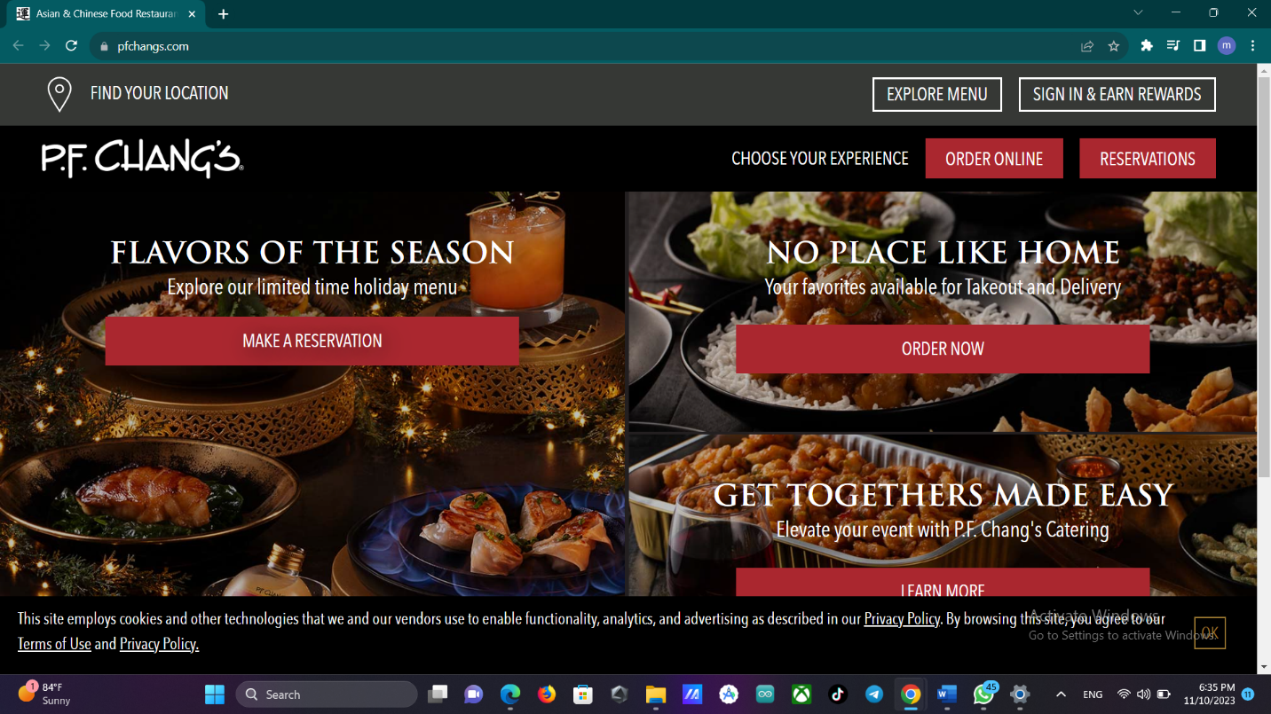

* **Their home page**

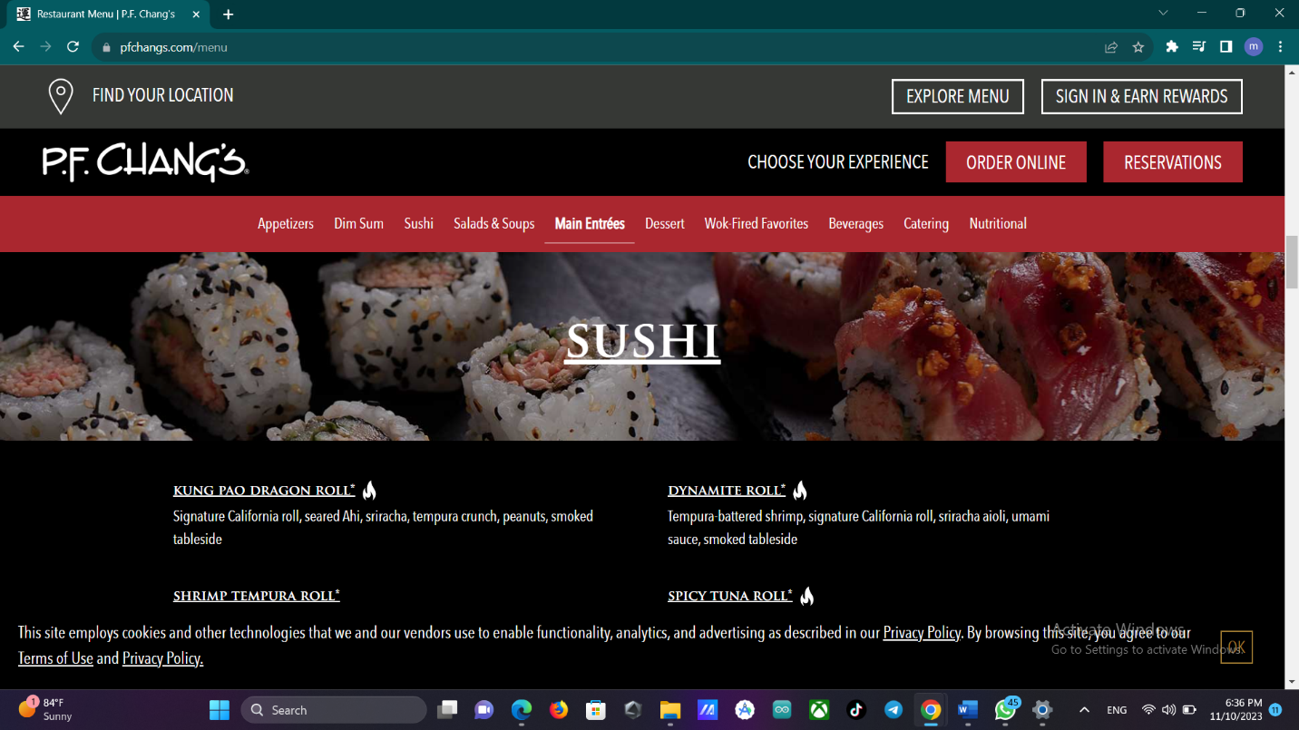

P.F. Chang's China Bistro's website is a well-structured digital platform that exudes reliability and offers a treasure trove of information for visitors. This celebrated restaurant specializes in Chinese and Asian cuisine, providing a diverse array of delectable food selections that cater to a wide range of tastes and preferences.

One of the website's standout features is its transparency regarding the restaurant's locations. It offers a user-friendly way for diners to find the nearest P.F. Chang's China Bistro, making it easy to plan visits to enjoy their exceptional Chinese and Asian dishes.

The visual appeal of the website is striking, featuring captivating photographs that capture the essence of the restaurant's ambiance and the mouthwatering dishes. These images immerse visitors in the culinary journey, providing a preview of the delightful experience that awaits at P.F. Chang's. The restaurant's commitment to creating an enticing atmosphere is evident through these visuals.

The website also excels in facilitating communication, providing various means to get in touch with the restaurant. Whether it's making reservations, seeking additional information, or sharing feedback, the website fosters easy interaction. This high level of accessibility enhances the overall customer experience, making the website user-friendly and customer-centric.

Furthermore, the website offers a wealth of information about the restaurant, allowing visitors to gain a deeper understanding of P.F. Chang's China Bistro. This includes details about the restaurant's history, its philosophy of using quality ingredients, and the stories behind certain signature dishes. This additional context adds layers of authenticity and transparency, helping customers form a more comprehensive picture of what to expect when dining at P.F. Chang's.

In summary, P.F. Chang's China Bistro's website is a reliable and information-rich digital platform that truly captures the essence of Chinese and Asian cuisine. It provides practical tools for locating restaurants and making reservations while immersing visitors in the culinary journey through engaging visuals and informative content. This website stands as a model for restaurants in the industry, emphasizing the importance of transparency and customer engagement.

***Red Lobster***

Red Lobster, a deified name in the world of seafood dining, is a seafood nut's paradise. With a heritage that spans decades, Red Lobster has set the standard for exceptional seafood cookery, furnishing an indelible dining experience that combines the finest seafood with a drinking air and top- notch service. One of the emblems of Red Lobster is its commitment to offering outside dining with stirring views. The eatery's setting is precisely curated to give guests with stunning lookouts of the ocean, creating an atmosphere that is both witching

and serene. The appeal of dining by the ocean, under the open sky, is an integral part of what makes Red Lobster a name seafood destination. As for the seafood itself, Red Lobster's menu is a treasure trove of flavors and choices. While seafood is at the heart of the cookery, the eatery goes over and further by offering an expansive selection of traditional and transnational dishes. Whether you are a addict of the classics or eager to explore new tastes, Red Lobster has commodity to satisfy every palate. From the succulent Garlic Prawns to the bold flavors of Tiger Prawns and the exquisite Barramundi, the eatery's menu is a festivity of the ocean's bounty. Red Lobster proudly stands as the original rooftop seafood eatery in Colombo, setting the standard for others to follow. Its long- standing history and commitment to culinary excellence have made it a cherished icon in the megacity’s dining scene. Guests can enjoy the honor of dining in a setting that captures the substance of the ocean, making it an ideal destination for special occasions or simply for those who appreciate the finer effects in life. The opening hours at Red Lobster are designed to accommodate guests from 5p.m. to 1130p.m., icing that beaneries can enjoy their seafood feast at their convenience. The evening setting adds an redundant subcaste of charm to the dining experience, with the sound of the swells and the ocean breath creating an alluring background to the mess. The fidelity to delivering an exceptional dining experience extends to the eatery's commitment to showcasing the prodigies of the ocean on every plate. The quality of the seafood is consummate, and Red Lobster takes great care in sourcing the freshest and finest constituents. From the moment the seafood is named to the way it's consummately set and presented, the eatery's culinary platoon ensures that each dish is a masterpiece in its own right. In addition to the tasteful seafood, Red Lobster's service is alternate to none. The staff is attentive, knowledgeable, and passionate about making every visit memorable. Whether you are a seafood dilettante or new to the world of ocean- inspired cookery, the platoon at Red Lobster is devoted to guiding you through the menu and helping you make choices that suit your preferences. In conclusion, Red Lobster isn't just a seafood eatery; it's an institution that defines the epitome of seafood dining. With its stirring outside setting, a menu that caters to a variety of tastes, and a heritage of excellence, Red Lobster offers an unexampled seafood experience. It's a destination where the ocean’s treasures come to life on your plate, and where every visit is a festivity of the ocean's bounty. Red Lobster is a testament to the love of seafood, an ode to outside dining, and an iconic seafood destination in Colombo that continues to make swells in the culinary world.

* **There home page**

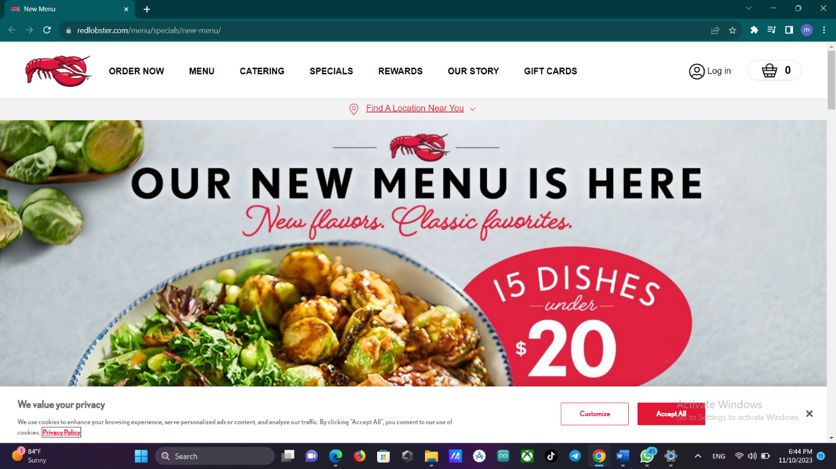

* **There menu**

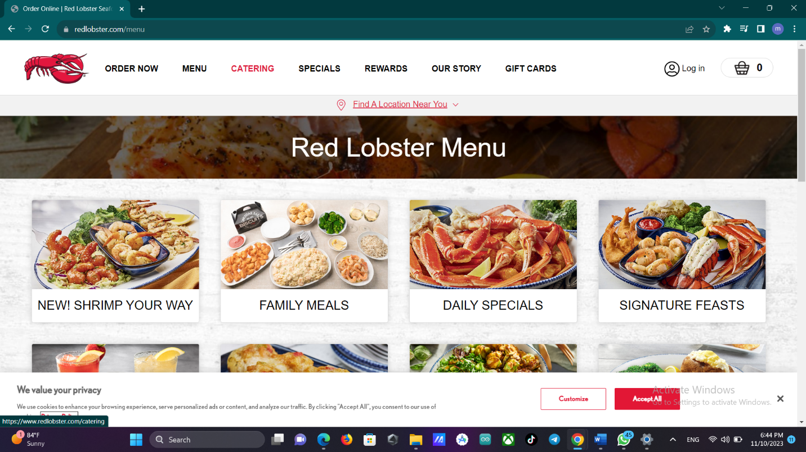

Red Lobster's website is a reliable digital platform that offers a wealth of information and an engaging stoner experience. This famed seafood eatery leaves no detail unattended, icing that callers have all the coffers they need to plan their perfect seafood dining experience. One of the website's strong suits is its clear donation of the eatery's colorful locales. Red Lobster makes it royal for beaneries to find the nearest eatery, making the seafood experience fluently accessible. The visual appeal of the website is inarguable. Engaging photos capture the substance of the ocean, the eatery's air, and the mouthwatering seafood dishes, immersing callers in the dining experience indeed before they arrive at the eatery. These images are a testament to Red Lobster's commitment to furnishing an enticing atmosphere. The website's functionality extends to easing communication, offering a range of ways to get in touch with the eatery. Whether it's making reservations, seeking fresh information, or participating feedback, the website fosters easy commerce. This position of availability enhances the overall client experience, making it a stoner-friendly platform. likewise, Red Lobster's website is a treasure trove of information about the eatery, allowing callers to gain a deeper understanding of the establishment. It goes beyond simply showcasing the menu and locales, furnishing perceptivity into the eatery's gospel, its commitment to quality, and indeed participating stories about the origins of certain dishes. This depth of content adds a subcaste of authenticity and translucency, giving guests a deeper connection to the dining experience they can anticipate. In summary, Red Lobster's website is a dependable and information-rich digital platform that encapsulates the substance of seafood dining. It provides practical tools for position discovery and reservations while also immersing callers in the seafood experience through engaging illustrations and instructional content. This website serves as a model for cuffs

in the assiduity, demonstrating the significance of translucency and client engagement.

Task 1

.b.

* **.Loading page**



* **.Home**

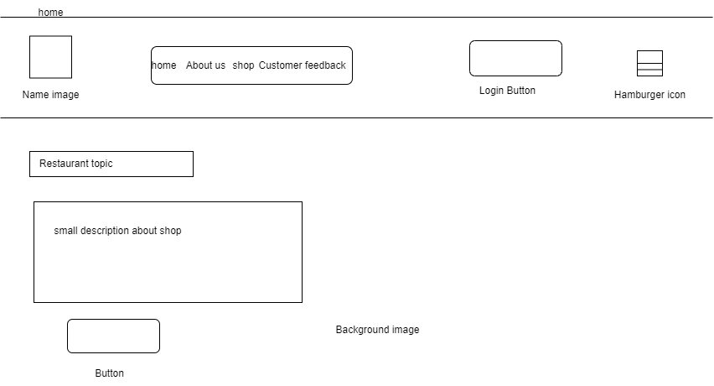

* **.Service box**

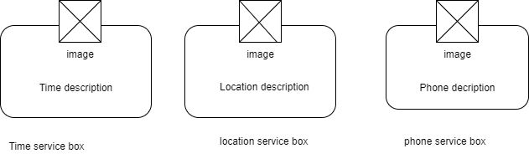

* **About-us**

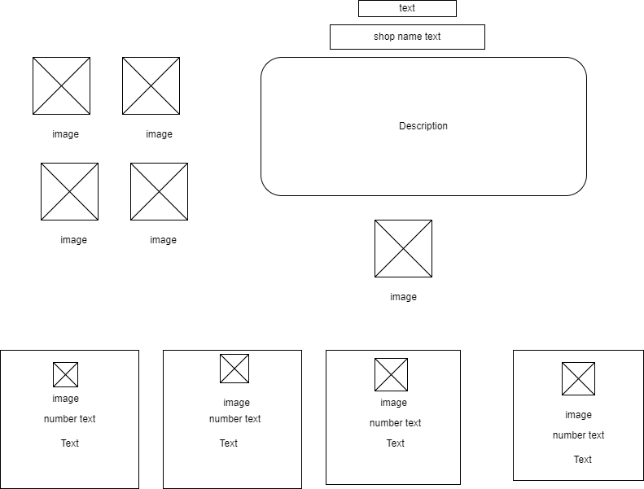

* **Shop-section**

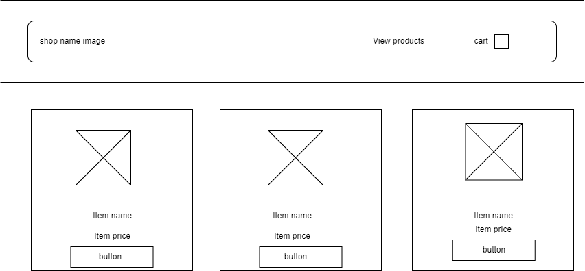

* **Customer feedbacks**

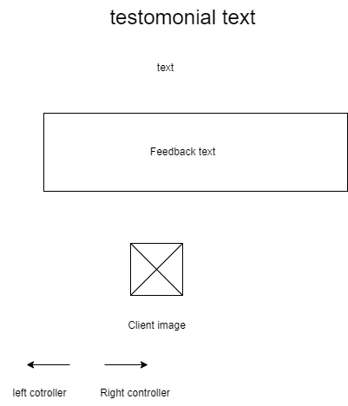

* **Login form**

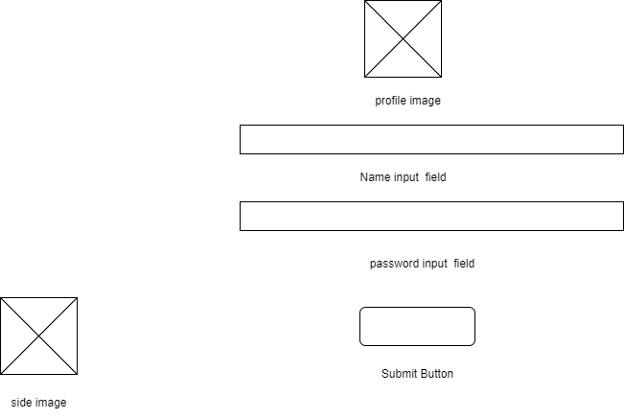

* Admin page

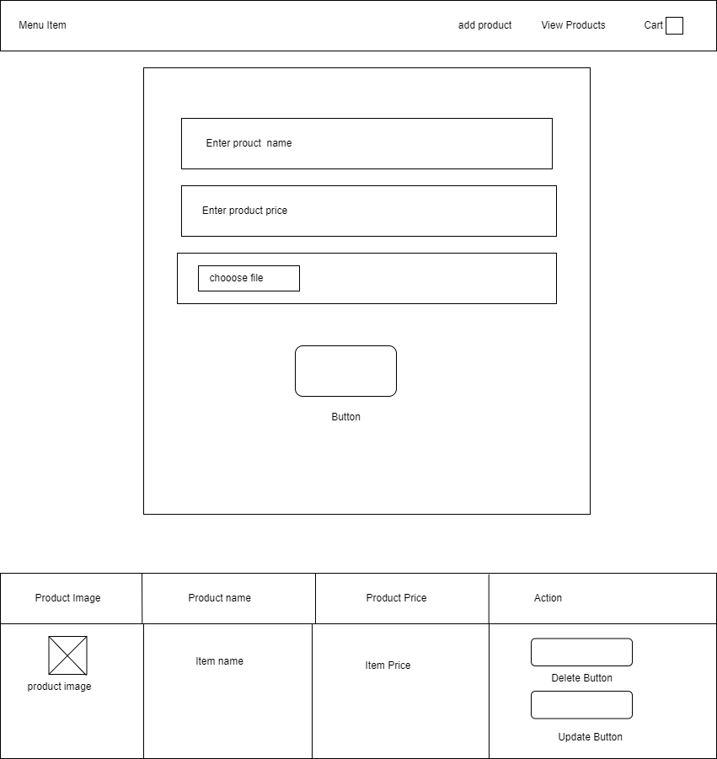

* Cart page

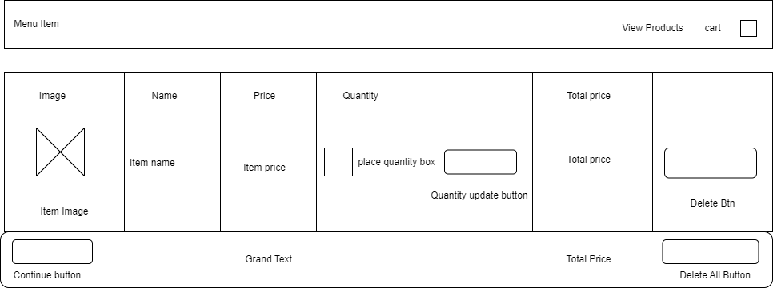

* Checkout page

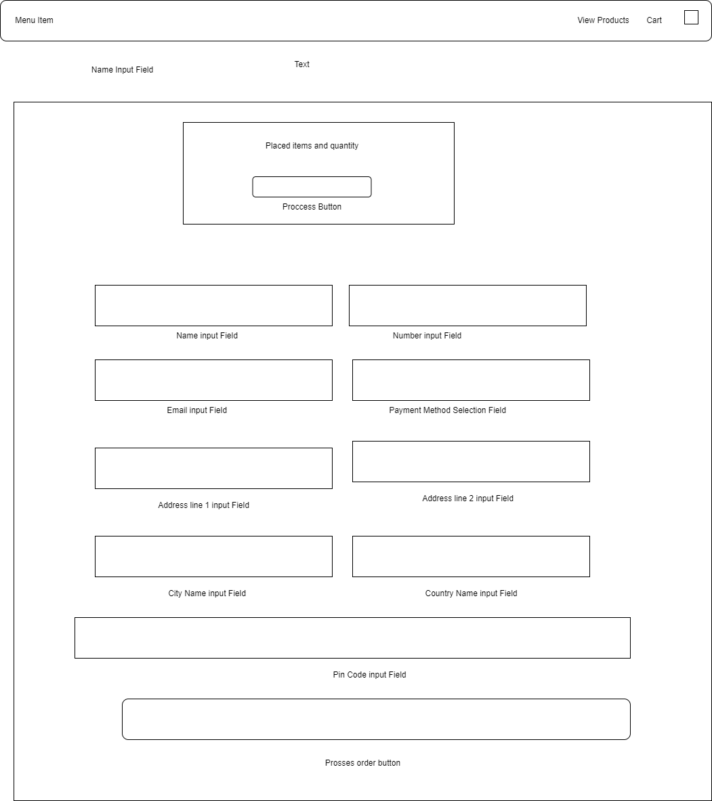

* Checkout msg

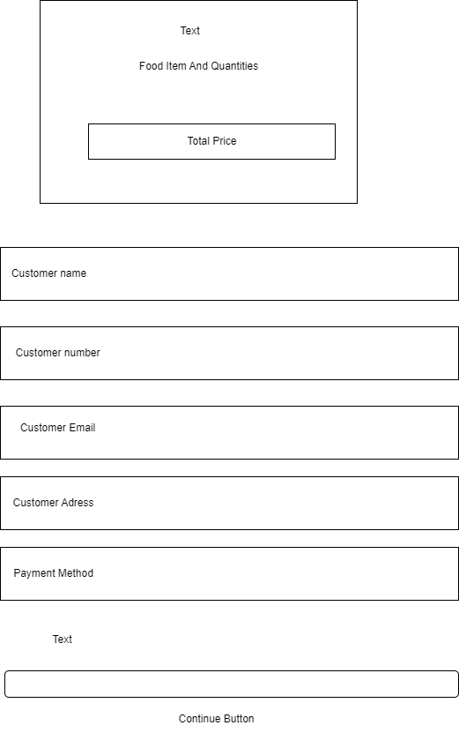

* Site map

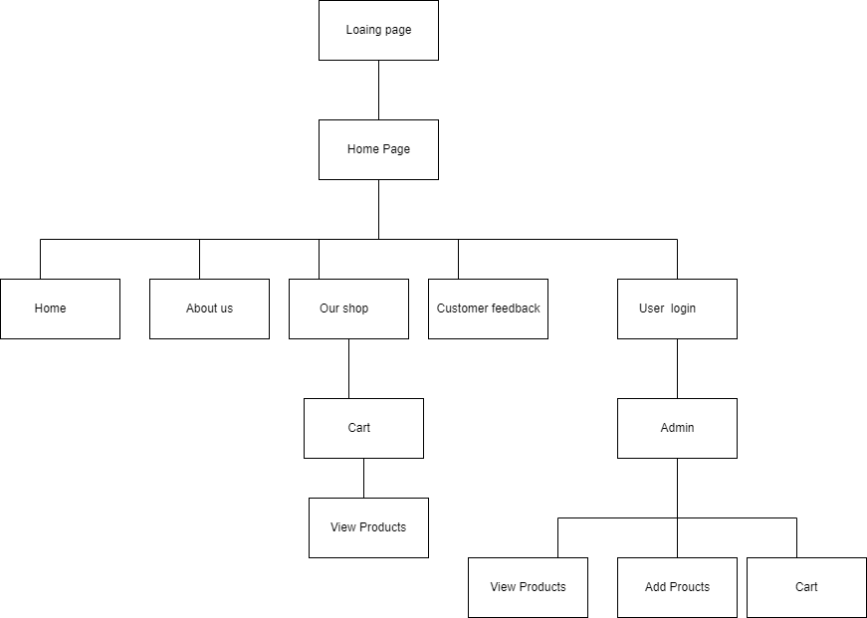

***Task 2***

1. Front-End

* **Loading-page**

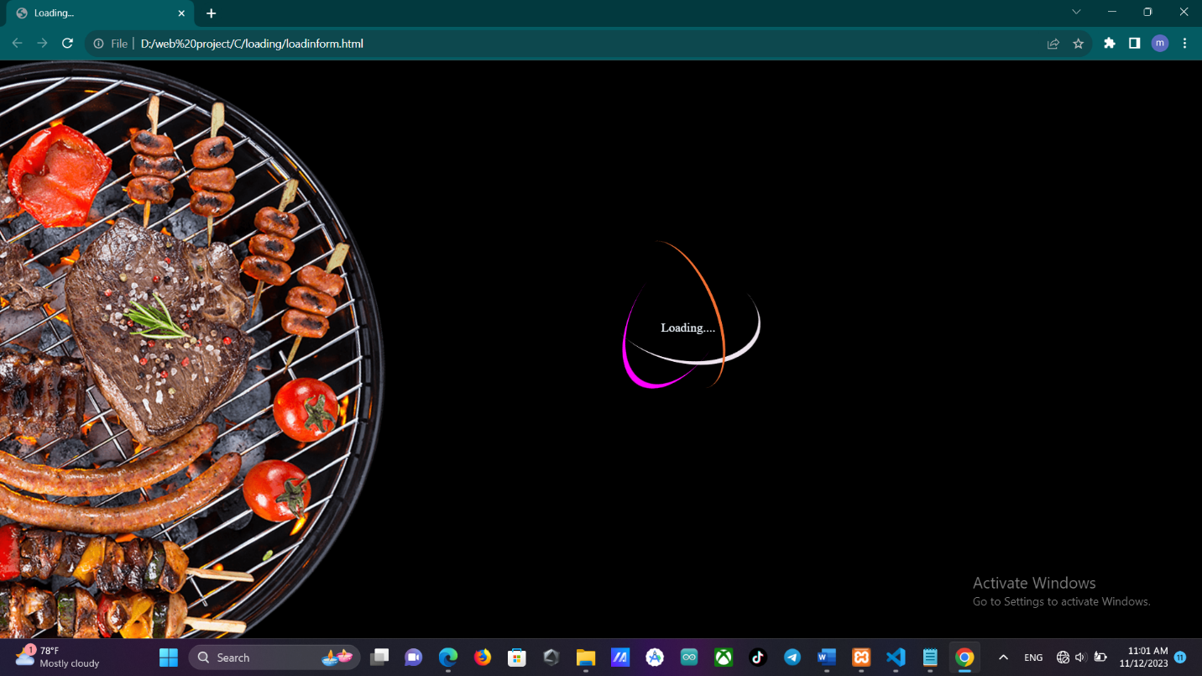

* **Home-page**

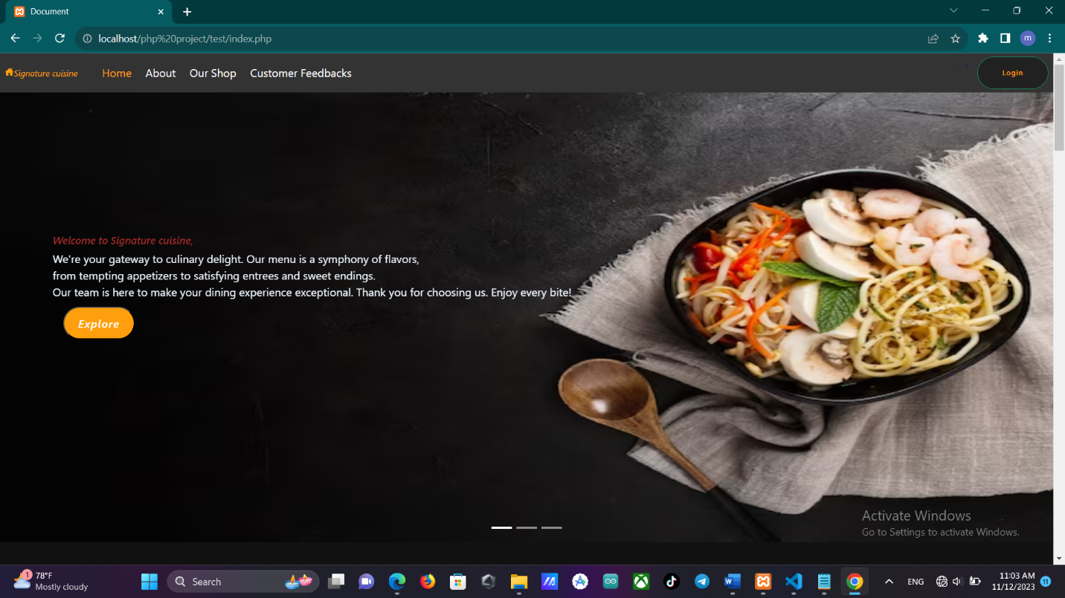

* **About-us page**

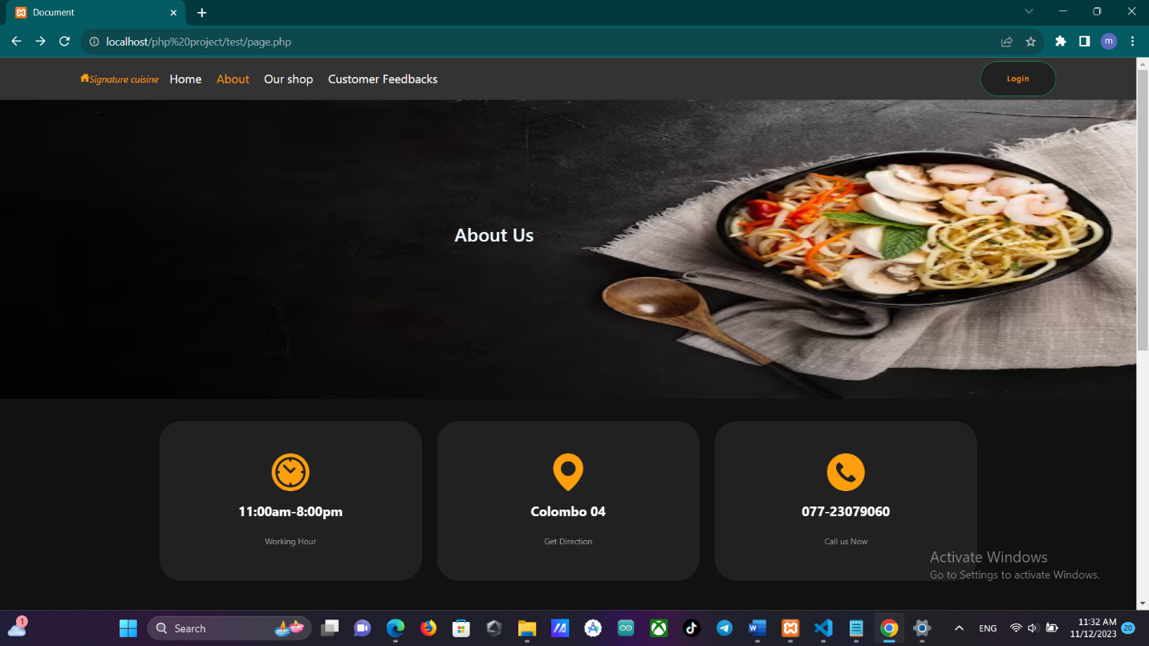

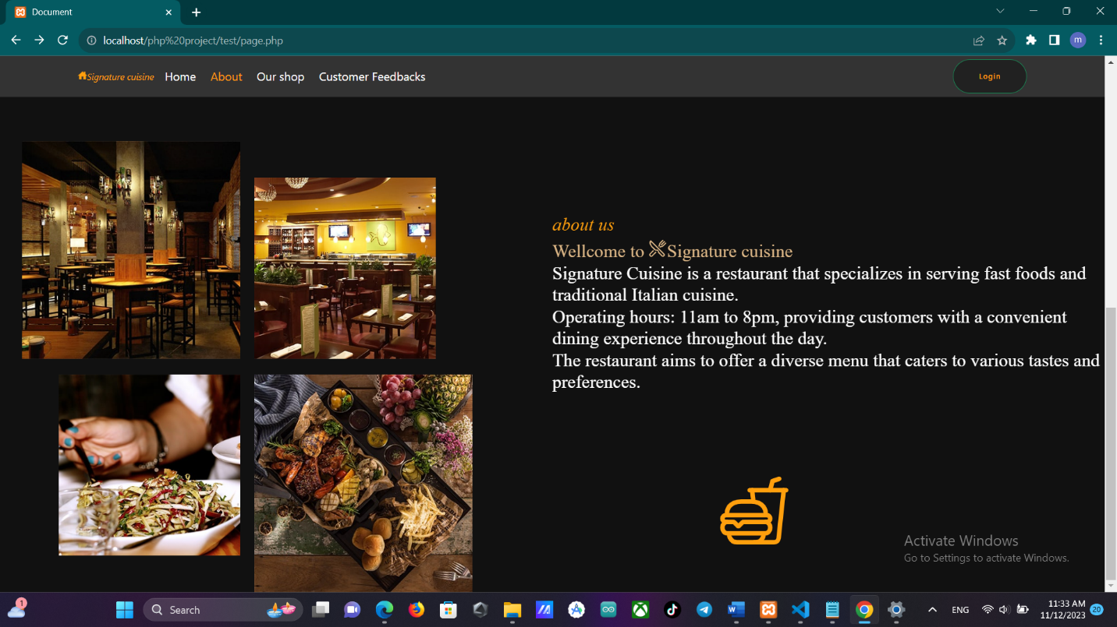

* **Food menu-page**

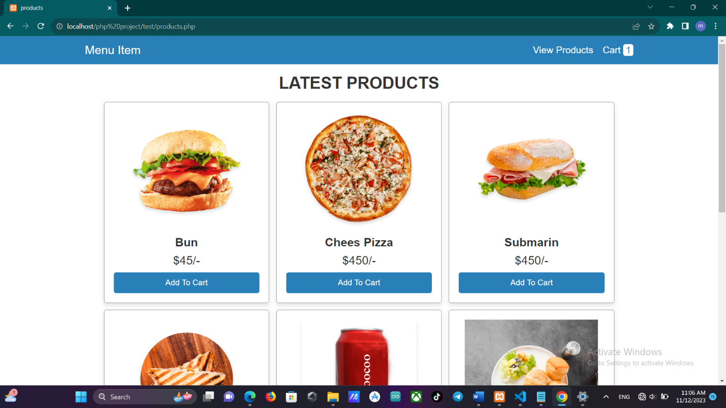

* **Customer feedback-page**

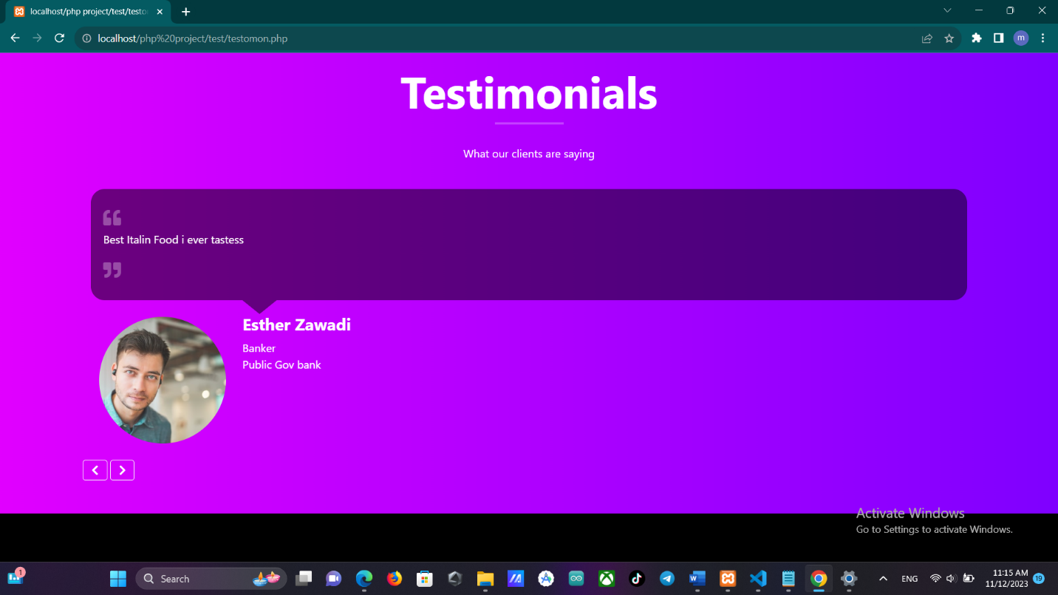

* **Login-page**

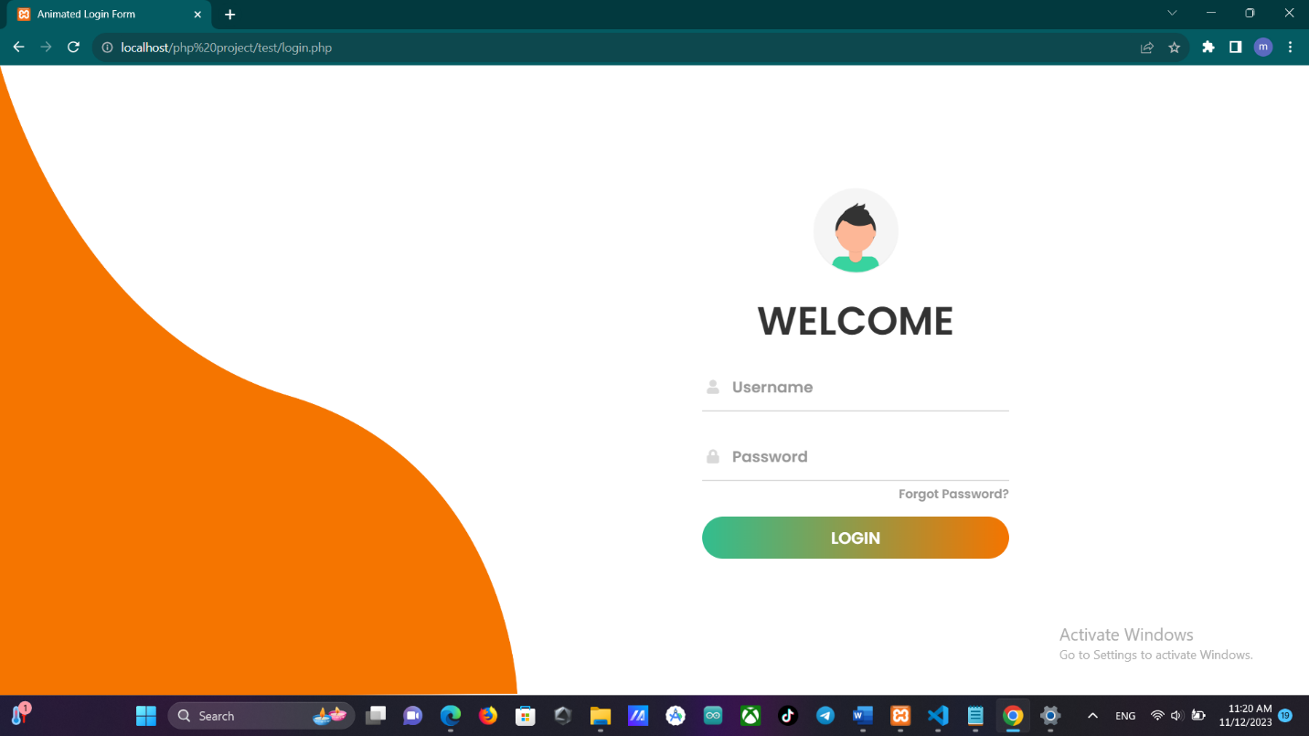

* **Admin-page**

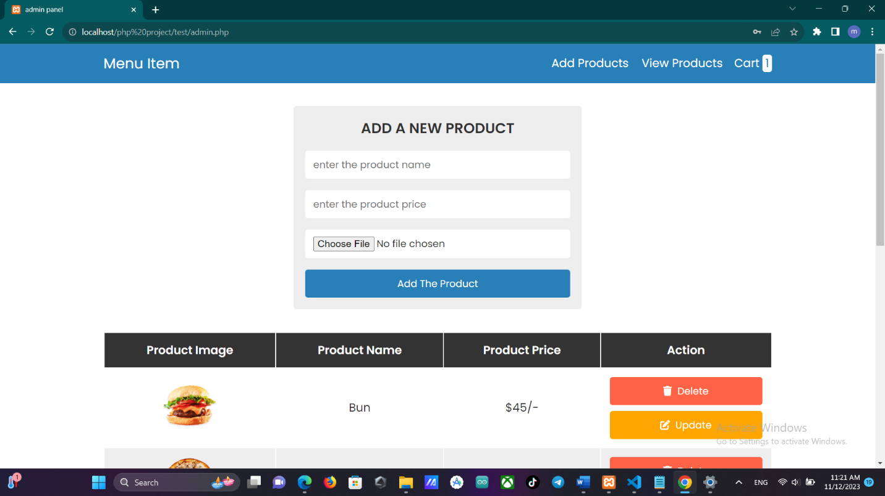

* **Cart-page**

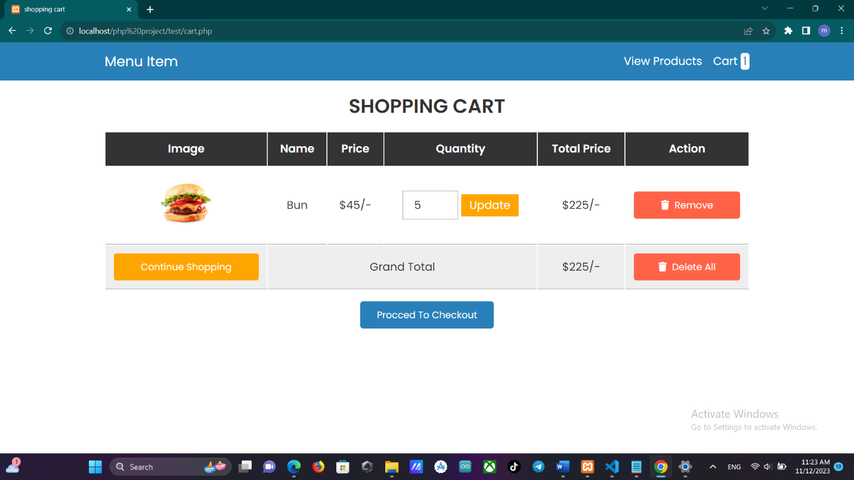

* **Checkout-page**

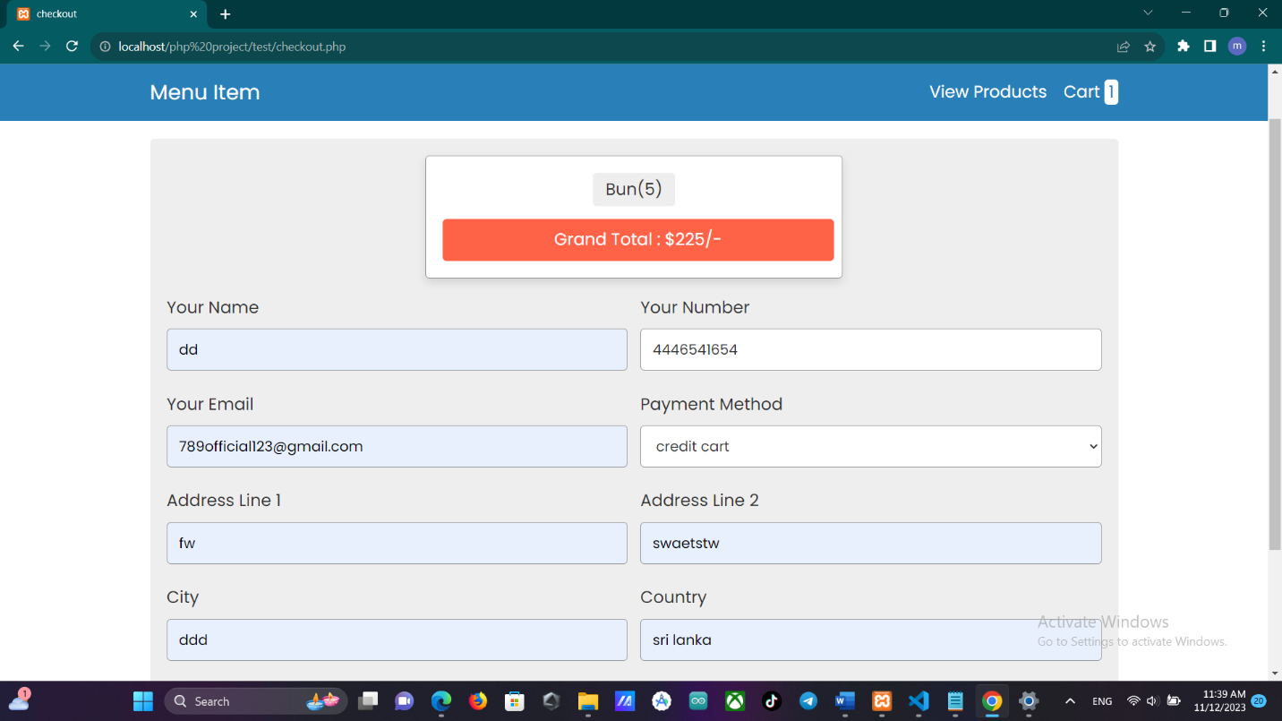

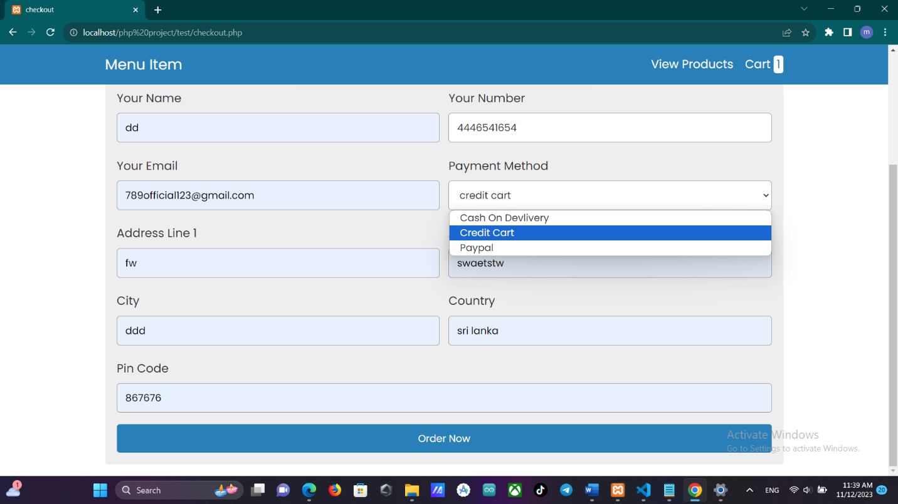

* **User-recipt**

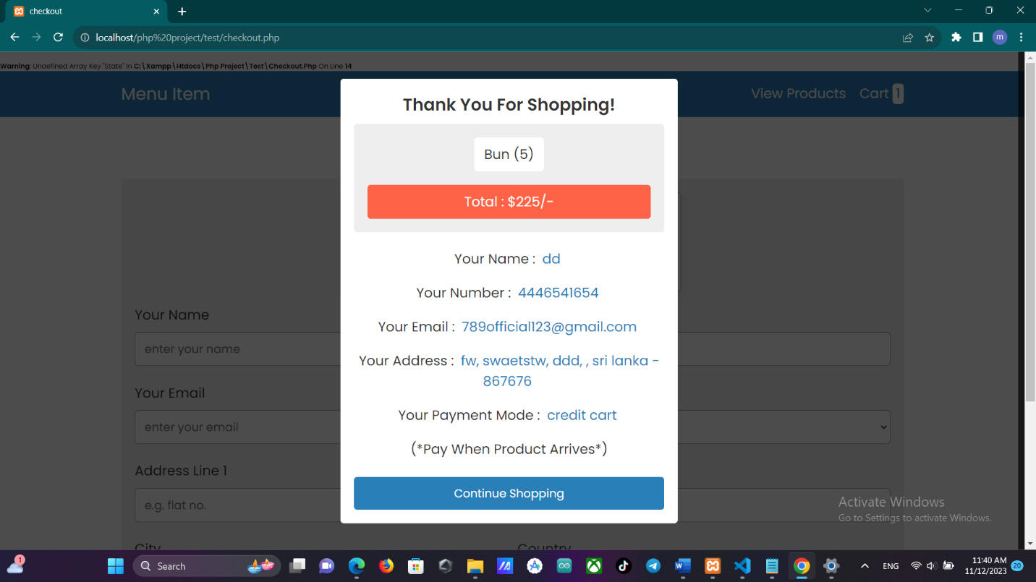

1. **Back-End**

* **Login**

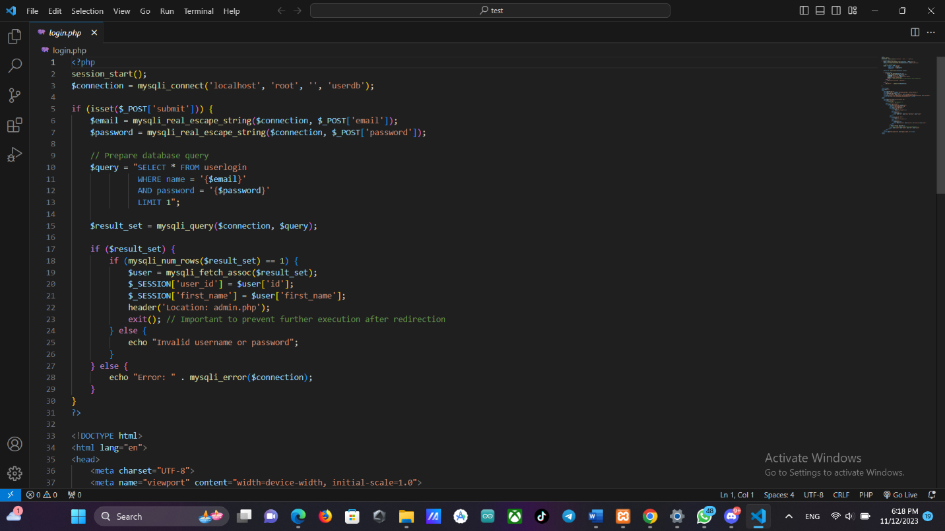

* **Admin**

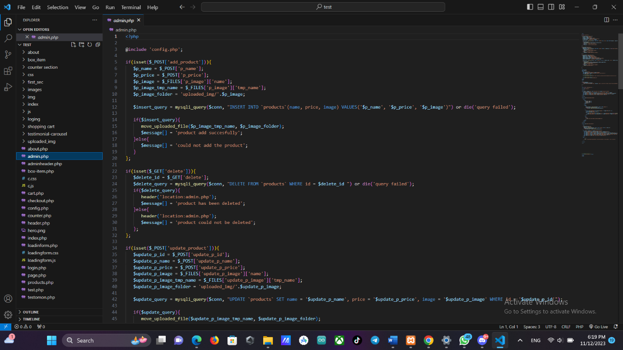

* **Cart**

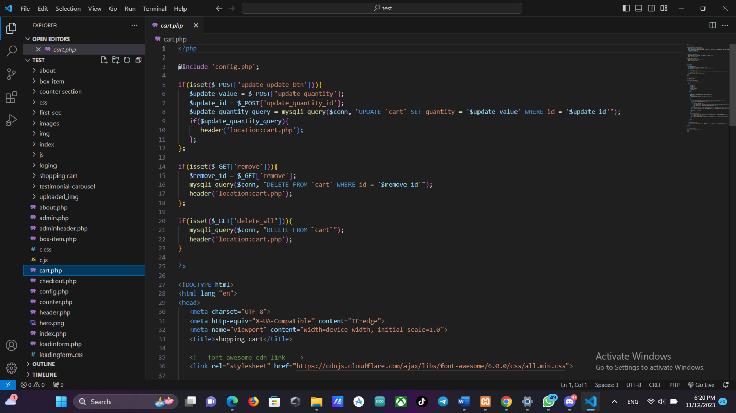

* **Food menu**

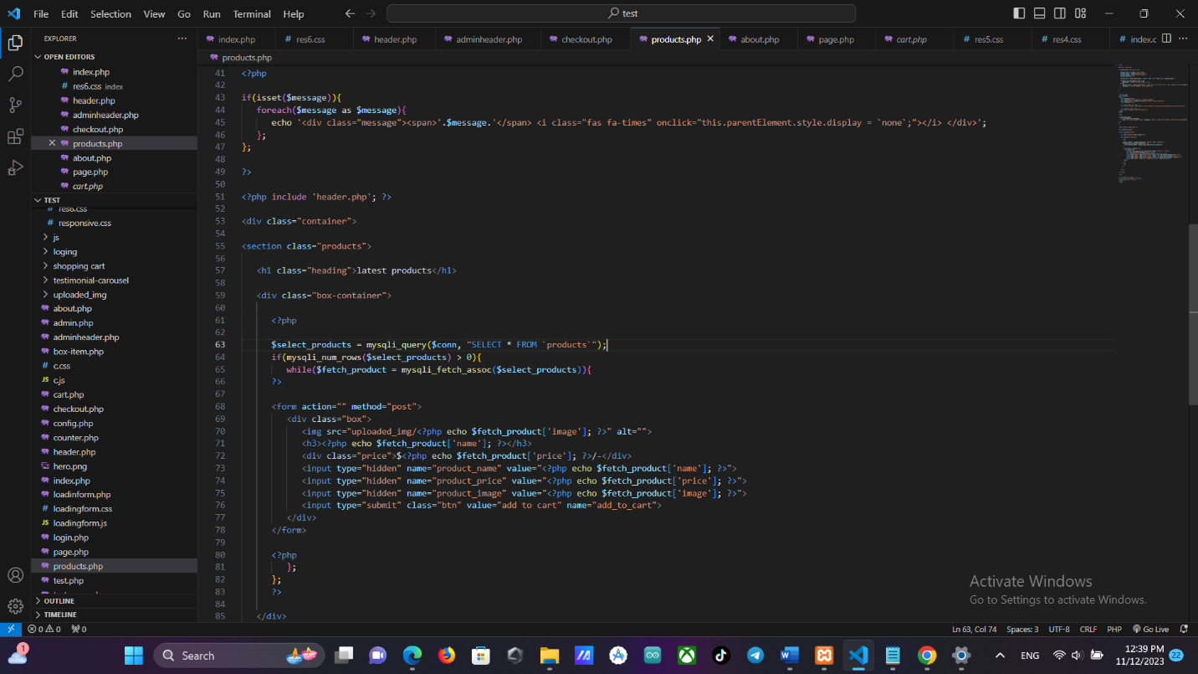

* **Header**

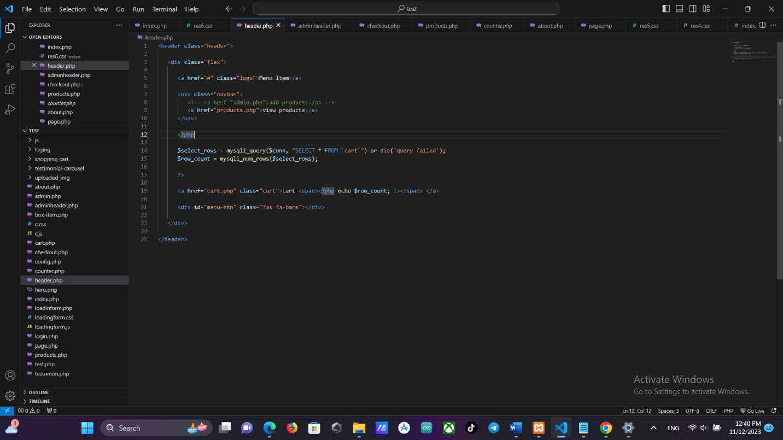

* **Checkout**

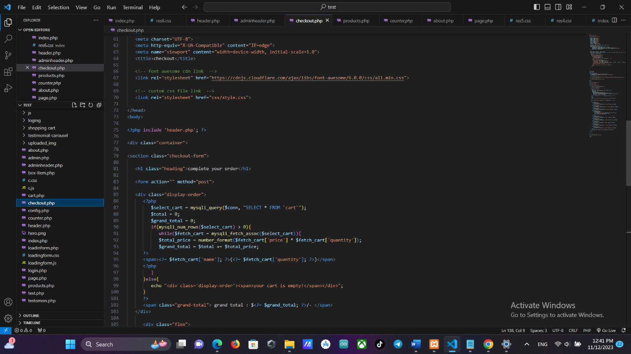

**Task 03**

1. **Testing Overview**

❖ Every button on this restaurant's website that links to a hyperlink operates perfectly. On this website, I've used a lot of animations and colors, and each one of them works correctly. I also used the form, and it displays properly. The website's back-end functionality (admin registration and login, customer registration and login, logout, reservation form, feedback form) are working. Various online browsers, including Chrome, Firefox, Safari, and Internet Explorer, are opening this website.

1. **Test Plan**

|  |  |  |  |
| --- | --- | --- | --- |
| Test case ID | Test case name | Scenario | Expected result |
| T01 | Login form | Enter data correctly | Display à “User name and passwords are correct” |
| T02 | Admin login | Enter correct email and password | Display à “If it is a customer goes to Customer form otherwise goes to Admin form” |
| T03 | Admin login | If email or password wrong | Display à “Email or password wrong” |
| T04 | Add products | Enter image path and Item Name And price | Display à “Display Product Added Succesfully” |
| T05 | Shop section | Ordered item placed in cart section | Display à “Display Massage item added successfully” |
| T06 | Shop section | If item already added into cart | Display à “Item already added into cart” |
| T07 | Cart | If customer clicked process to checkout button | Display à “Item place to checkout” |

|  |  |  |  |
| --- | --- | --- | --- |
| T08 | Checkout | Fill all entities | Display à “Display Customer detailes to confirm” |
| T09 | Delete an item | If admin click delete on item form | Display à “An will be item  removed from the item form” |
| T10 | update an item | If admin click update on item form | Display à “An will be item  update from the item form” |

1. **Test Case**

|  |  |
| --- | --- |
| ID | T02 |
| Name | Login form |
| Scenario | Enter proper details |
| Input Data | Email, password |
| Expected Result | Data added successfully |
| Actual Result | Data added successfully |
| Screenshot |  |
| Conclusion | Works perfectly |

|  |  |
| --- | --- |
| ID | T03 |
| Name | Login form |
| Scenario | If the email or password wrong |
| Input Data | Display à “incorrect name or password” |
| Expected Result | incorrect name or password |
| Actual Result | incorrect name or password |
| Screenshot |  |
| Conclusion | Not working |

|  |  |
| --- | --- |
| ID | T04 |
| Name | Add products |
| Scenario | Add items to menu |
| Input Data | Item name, item price , item price |
| Expected Result | Item added to menu successfullly |
| Actual Result | Item added to menu successfully |
| Screenshot |  |
| Conclusion | Works perfectly |

|  |  |
| --- | --- |
| ID | T05 |
| Name | Add products |
| Scenario | Didn’t fill all input fields |
| Input Data | Item image, Item price, Item name |
| Expected Result | Didn’t add all data |
| Actual Result | Didn’t add all data |
| Screenshot |  |
| Conclusion | Not working |

|  |  |
| --- | --- |
| ID | T06 |
| Name | Shop-section |
| Scenario | Display proper details |
| Input Data | User Choice |
| Expected Result | Adding user choice to cart successfully |
| Actual Result | Adding user choice to cart successfully |
| Screenshot |  |
| Conclusion | Works perfectly |

**Feedback evaluation**

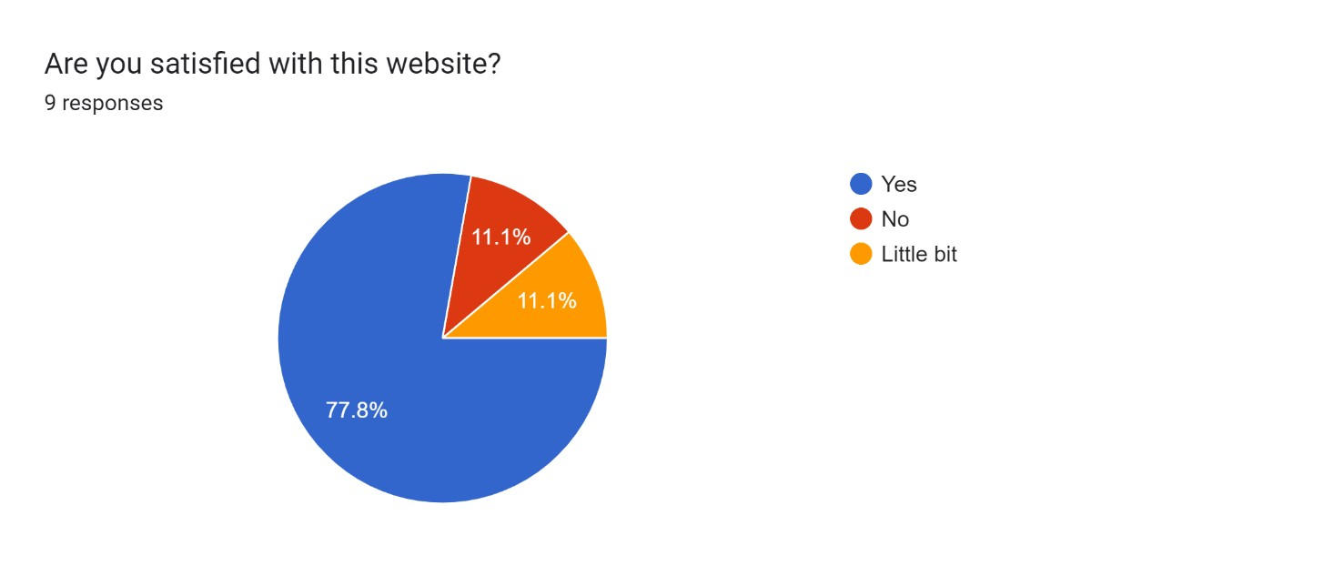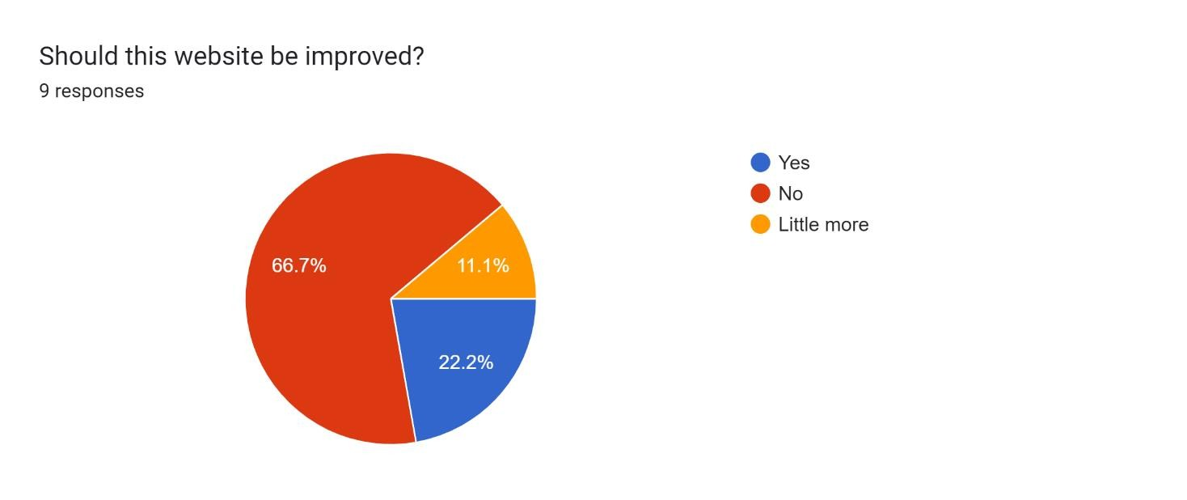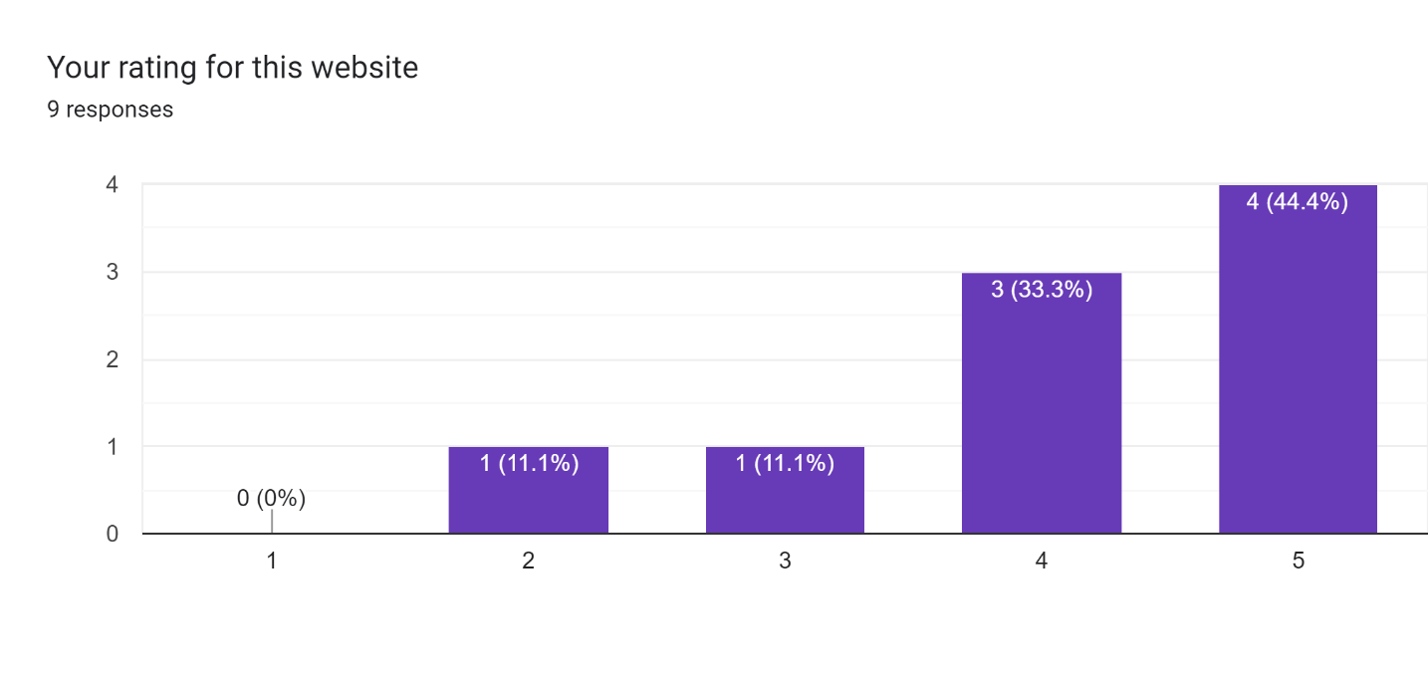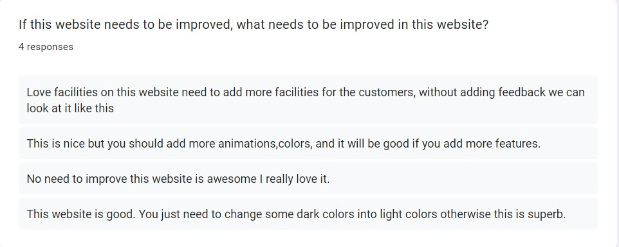

**Reference**

*The cheesecake factory*. Available at: https://www.thecheesecakefactory.com/ (Accessed: 12 November 2023).

*Olive garden Italian restaurant | family style dining | Italian food*. Available at: https://www.olivegarden.com/home (Accessed: 12 November 2023).

*The cheesecake factory*. Available at: https://www.thecheesecakefactory.com/ (Accessed: 12 November 2023).

*The cheesecake factory*. Available at: https://www.thecheesecakefactory.com/ (Accessed: 12 November 2023).